

**JavaTech Group**



**Payroll Management System for Information Technology Company**

**Use-Case Specification: Add User**

Version 1.0

**Table of Contents**

1. Ordering Book 3

1.1 Brief Description 3

1.2 Actor 3

2. Flow of Events 3

2.1 Basic Flow 3

3. Special Requirements 4

4. Preconditions 4

5. Postconditions 4

6. Extension Points 4

**Use-Case Specification: Add User**

# Ordering Computer

## Brief Description

This use case defines the step of add user. Admin can easily add new user from the system by clicking the create button and fill the information to input form.

## Actor

Admin.

# Flow of Events

## Basic Flow

From the manage employee view, the admin click add user button. The admin then fill all the user information to input form and click save to complete the adding user.

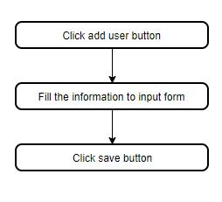

***Basic flow of add user***

# Special Requirements

No special requirements.

# Preconditions

No preconditions.

# Postconditions

The admin checks the user’s information after add to ensure the adding process is complete.

# Extension Points

No Extension point.